Chapter 2, Problem 45.

Find the equivalent resistance at terminals a-b of each circuit in Fig. 2.109.

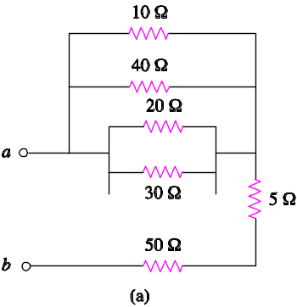

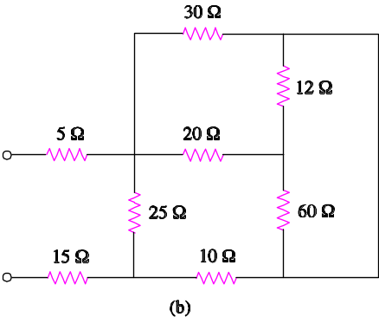

Figure 2.109
For Prob. 2.45.

